Supplementary Figure Legends：

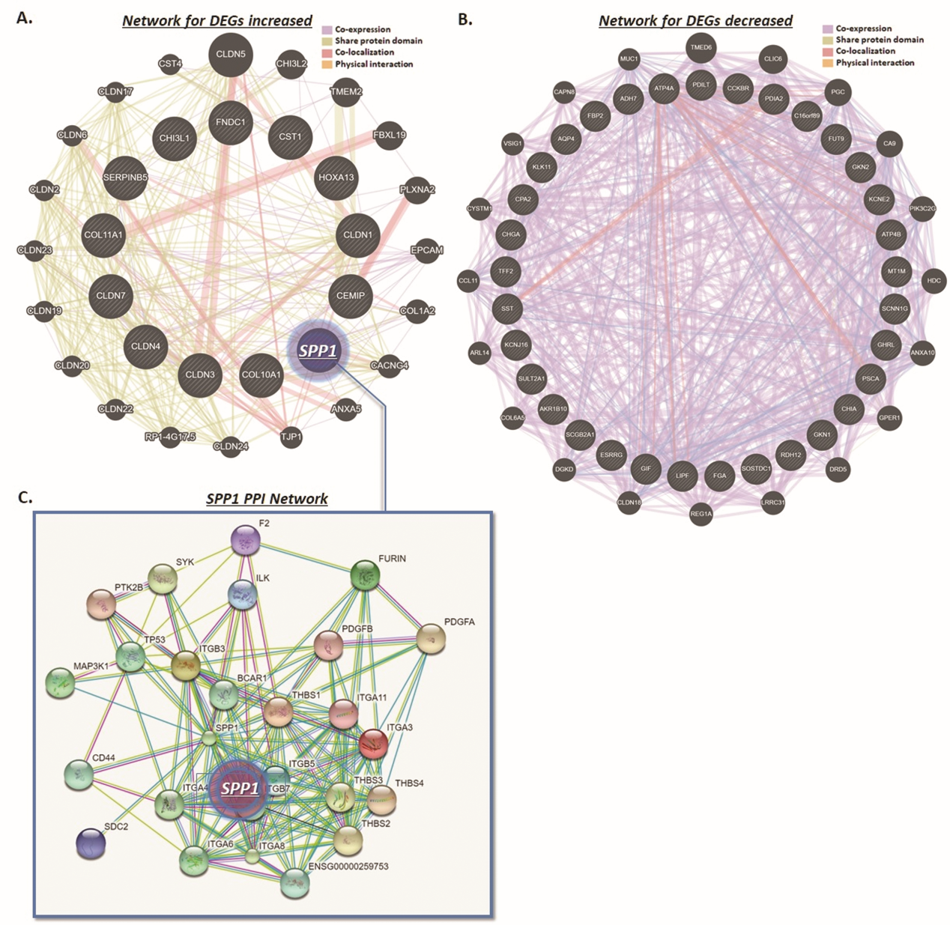
Suppl. Fig. 1. Networks of the DEGs, including SPP1
STRING database analysis was applied to establish the network of the DEGs. A. Network involves in molecular interaction and functional pathway in DEGs increased in GC. B. Network involves in molecular interaction and functional pathway in DEGs decreased in GC. C. Amplification of the network associated with SPP1, which demonstrates an integrative network between SPP1 and proteins pivotal in tumorigenesis and process.

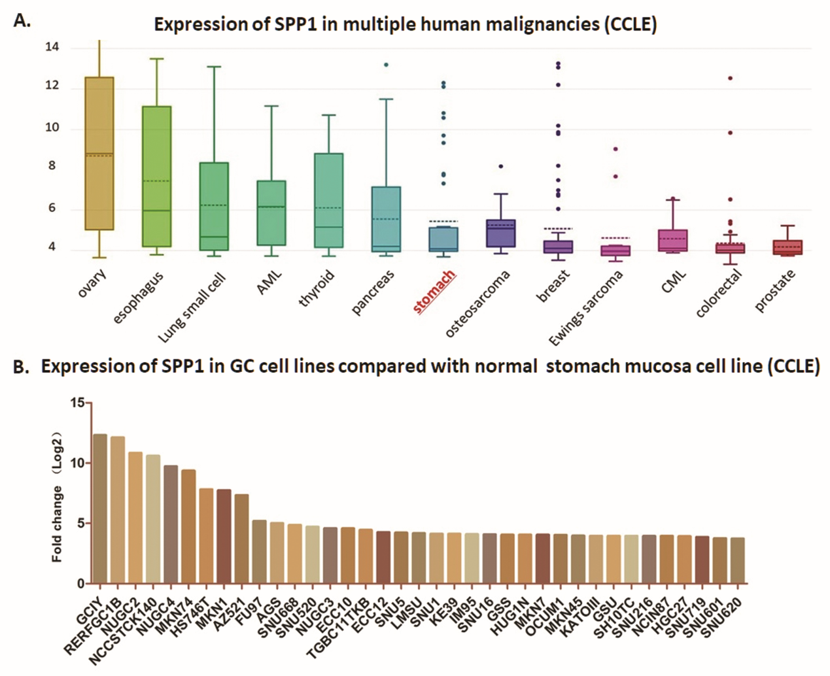
Fig. 2. SPP1 expression profile of the datasets from CCLE database
A. SPP1 expression (fold changes) in differential human malignancies from CCLE database; SPP1 presents highly expression level in multiple human malignancies, including GC. B. SPP1 expression in different GC cell lines from CCLE database.

